ABC’s Inventory Management System

Manage Product (Add Product Item) Test Scripts

Table of Contents

APIT001- Add a Product Item after adding a new Product by entering accurate details 3

Data Set 1 4

APIT002- Add a Product Item from existing Product by entering accurate details 7

Data Set 1 8

APIT003- Add a Product Item from existing Product by entering accurate details but skip some details. 11

Data Set 1 12

Data Set 2 14

APIT004- Add a Product Item from existing Product by entering invalid Quantity data 17

Data Set 1 17

Data Set 2 20

# APIT001- Add a Product Item after adding a new Product by entering accurate details

|  |  |  |  |  |  |
| --- | --- | --- | --- | --- | --- |
| **Test Name** | | Test add a Product Item after adding a new Product by entering accurate details (Test APIT001) | | | |
| **Use Case Tested** | | Manage Product | | | |
| **Test Description** | | This test tests if the system can add a new product item after adding a new product. | | | |
| **Pre-Conditions** | | Users need be logged in as a Warehouse Staff (Warehouse Staff Access) in the Manage Product page  Meta data to store Product Item details in the database must exist. | | | |
| **Post-Conditions** | | Product Item is added to the database. | | | |
| **Result (Pass/Fail/Warning/ Incomplete)** | | Pass | | | |
|  | **Test Step** | | **Expected Test Results** | **P** | **F** |
| 1. | Add a new product following the steps to add a new product as demonstrated in the ‘Add Product Test’. | | A new product is added, and the system prompts the user to assign product of variable sizes to a location (Add product item and stored product). | P |  |
| 2. | Enter accurate details in all fields. | | System waits until user clicks on ‘Add’ icon. | P |  |
| 3. | Click on ‘Add’ icon. | | System adds the entered quantity of product of the entered size to the database and displays an appropriate message. | P |  |
| 4. | Click on ‘Ok’. | | System displays the ‘Add Product Item/ Stored Product’ Page and waits for user to assign products of the same product code to a Location | P |  |

## Data Set 1

|  |  |
| --- | --- |
| **Data Set 1** | |
| **Fields** | **Values** |
| **Product Code** | L2 |
| **Product Size** | XS (L2100) |
| **Location** | Newtown Warehouse |
| **Quantity** | 5 |

**Step 1**

Adding a new product L2 to the system.

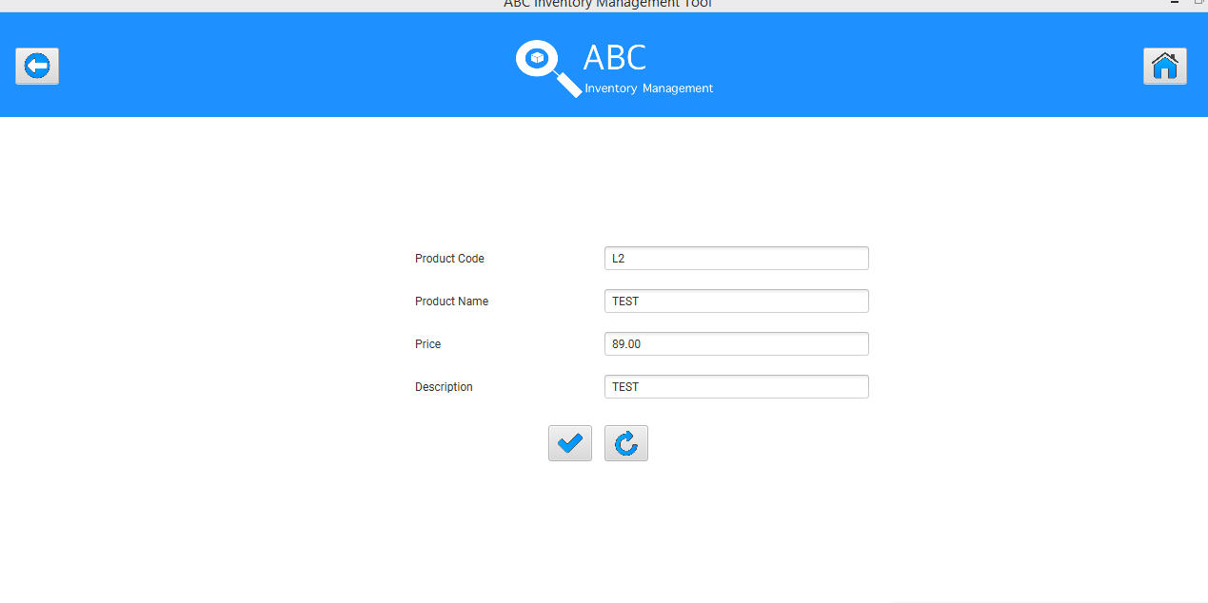

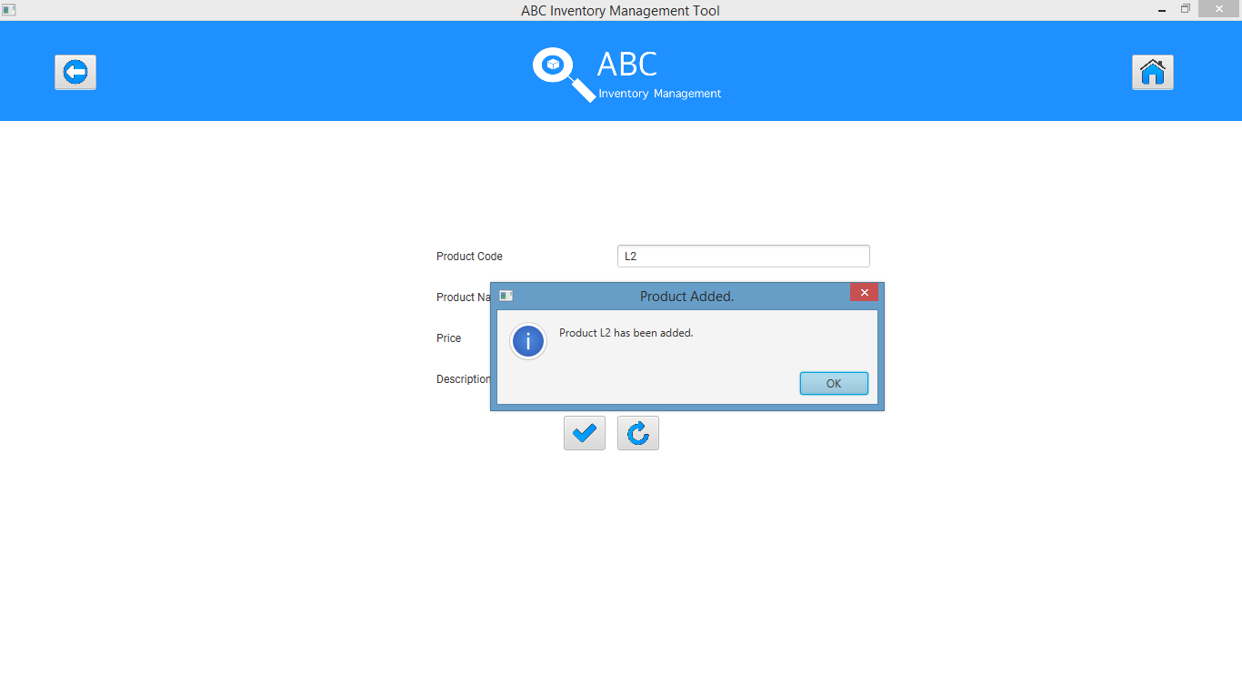

After clicking on ‘OK’ system displays the ‘Add Product Item/ Stored Product’ Page.

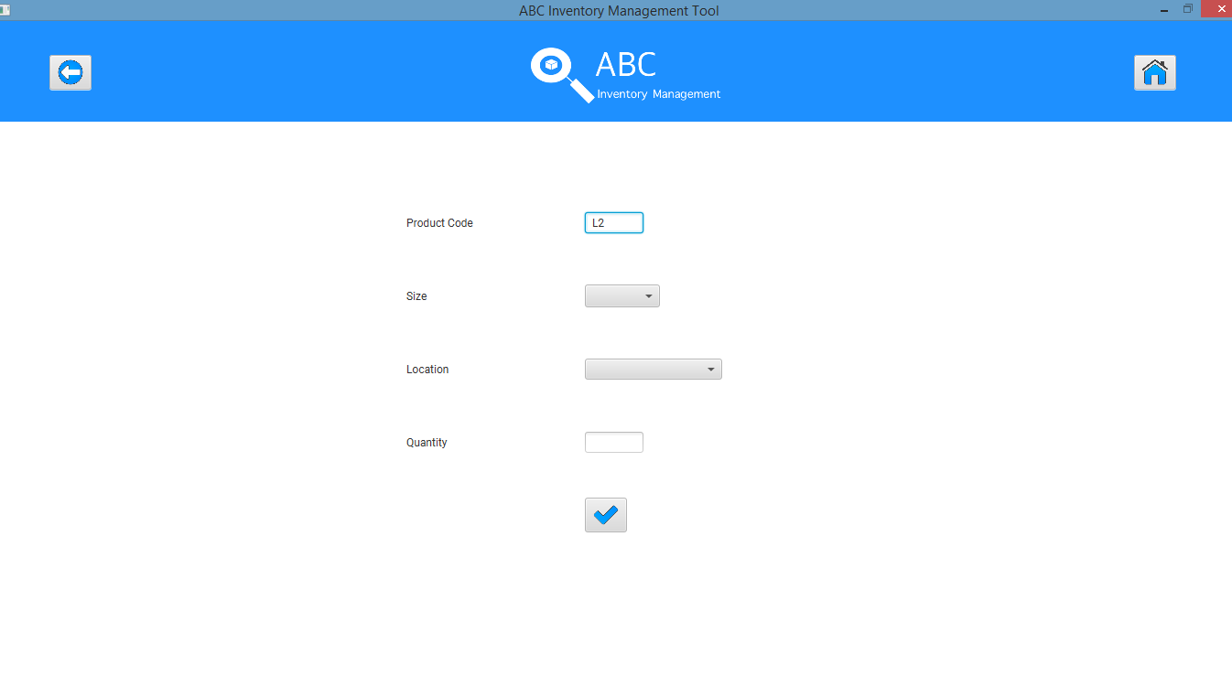

**Step 2**

Enter all details accurately to assign quantity 5 of size XS (Product Item L2100) to Newtown Warehouse.

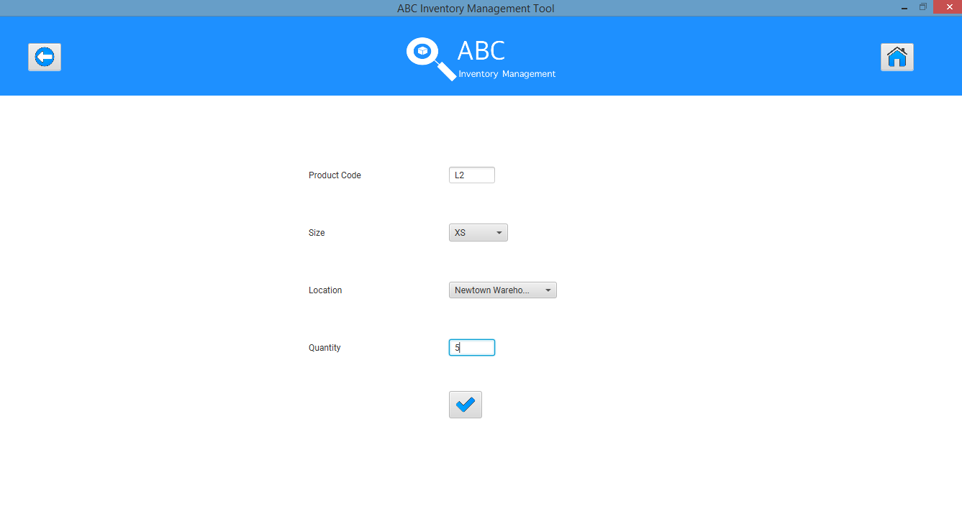

**Step 3**

System displays appropriate message.

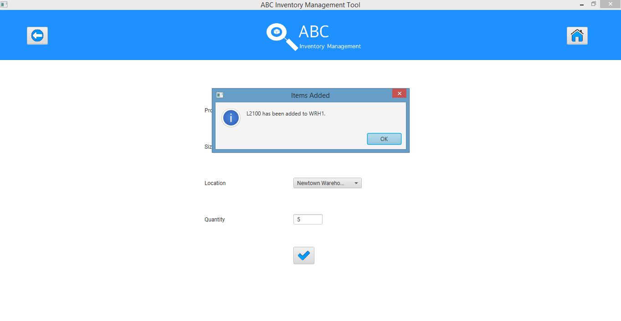

**Step 4**

After clicking on ‘Ok’ system displays the ‘Add Product Item/ Stored Product’ page for user to enter more product item/ stored product.

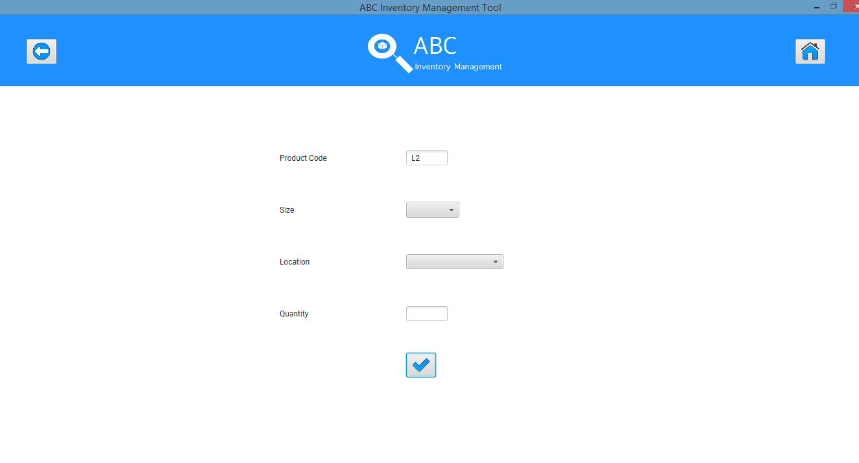

# APIT002- Add a Product Item from existing Product by entering accurate details

|  |  |  |  |  |  |
| --- | --- | --- | --- | --- | --- |
| **Test Name** | | Test add a Product Item from existing Product by entering accurate details (Test APIT002) | | | |
| **Use Case Tested** | | Manage Product | | | |
| **Test Description** | | This test tests if the system can add a new product item from an existing product. | | | |
| **Pre-Conditions** | | Users need be logged in as a Warehouse Staff (Warehouse Staff Access) in the Manage Product page  Meta data to store Product Item details in the database must exist. | | | |
| **Post-Conditions** | | Product Item is added to the database. | | | |
| **Result (Pass/Fail/Warning/ Incomplete)** | | Pass | | | |
|  | **Test Step** | | **Expected Test Results** | **P** | **F** |
| 1. | Click on ‘Add Product Item’ Icon for a particular product. | | Add Product Item/ Stored Product page is displayed for the product selected. | P |  |
| 2. | Enter accurate details in all fields. | | System waits until user clicks on ‘Add’ icon. | P |  |
| 3. | Click on ‘Add’ icon. | | System adds the entered quantity of product of the entered size to the database and displays an appropriate message. | P |  |
| 4. | Click on ‘Ok’. | | System displays the ‘Add Product Item/ Stored Product’ Page and waits for user to assign products of the same product code to a Location | P |  |

## Data Set 1

|  |  |
| --- | --- |
| **Data Set 1** | |
| **Fields** | **Values** |
| **Product Code** | L2 |
| **Product Size** | S (L2200) |
| **Location** | Newtown Warehouse |
| **Quantity** | 5 |

**Step 1**

Manage Product Page to enter a new Product Item from an existing Product.

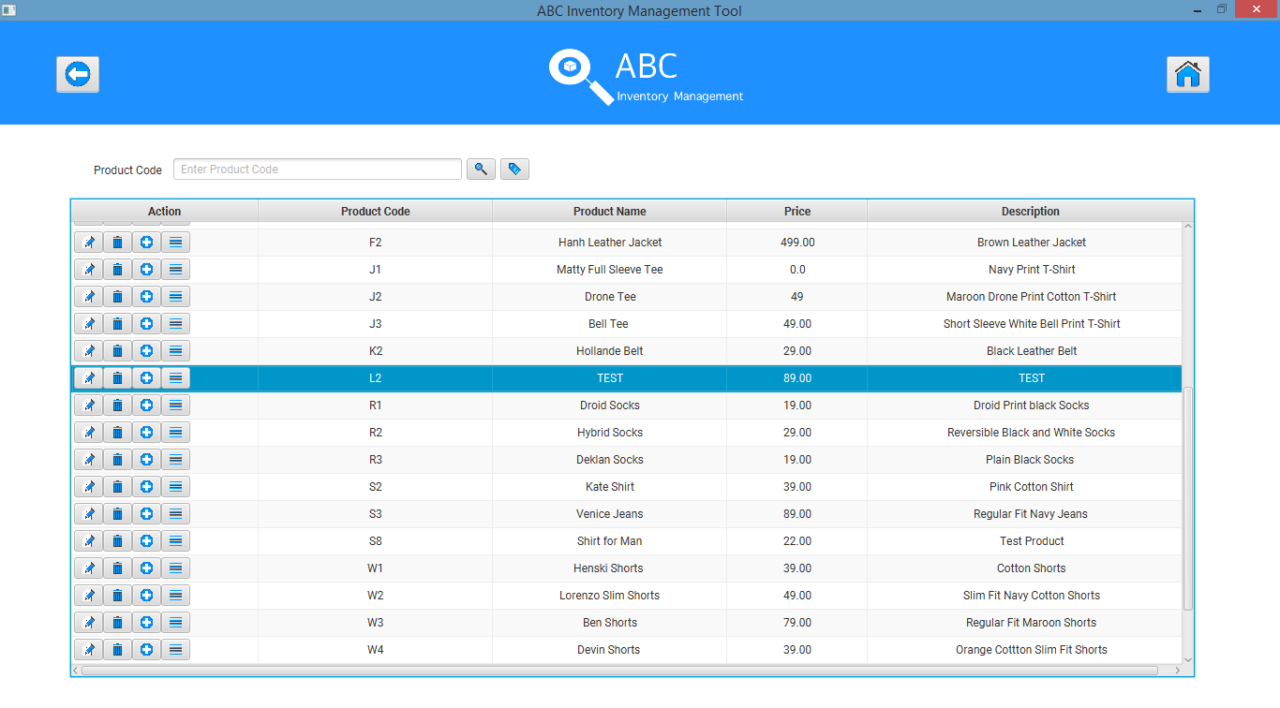

Add Product Item/ Stored Product page is displayed for the selected Product.

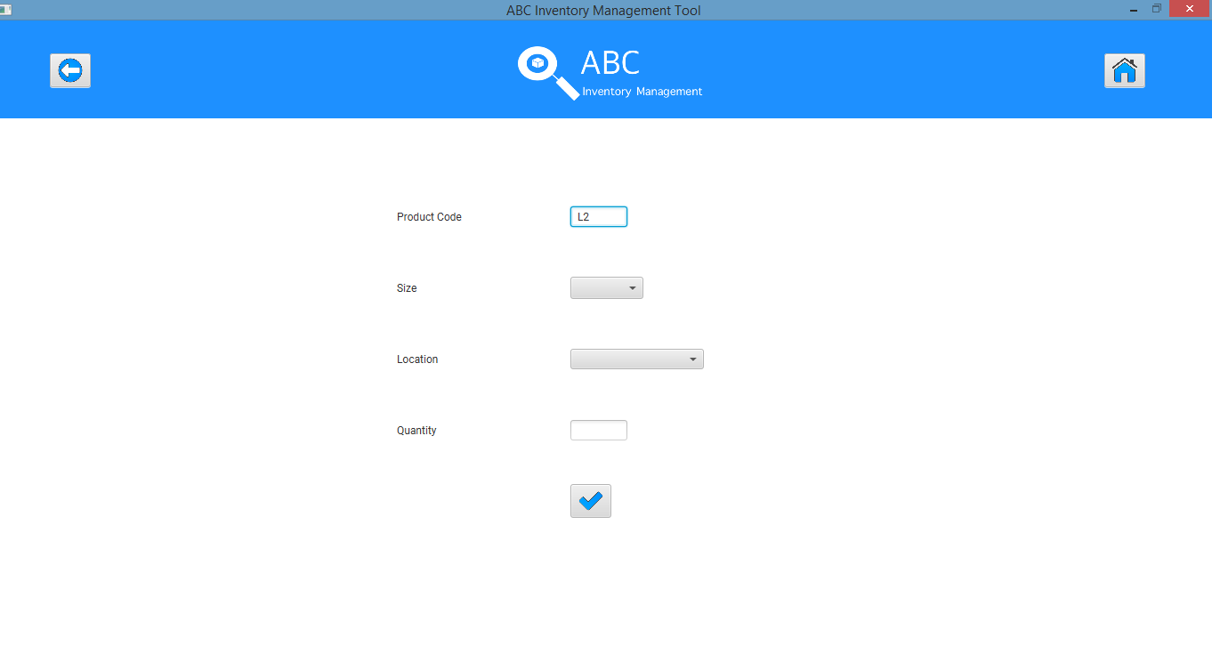

**Step 2**

Enter all details accurately and click on ‘Add’

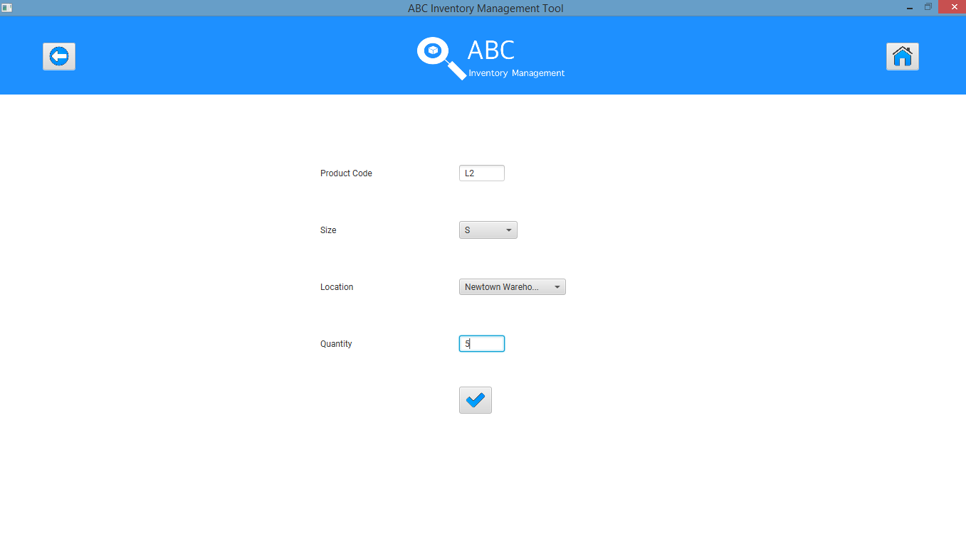

**Step 3**

System displays an appropriate message. User clicks on ‘Ok’.

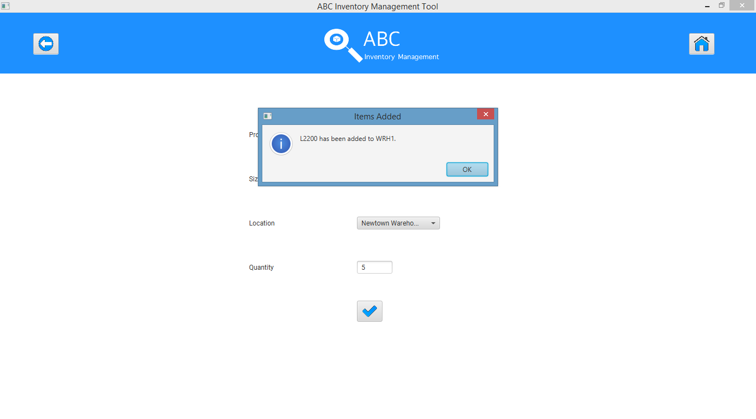

**Step 4**

System displays the ‘Add Product Item/ Stored Product’ Page for the selected product.

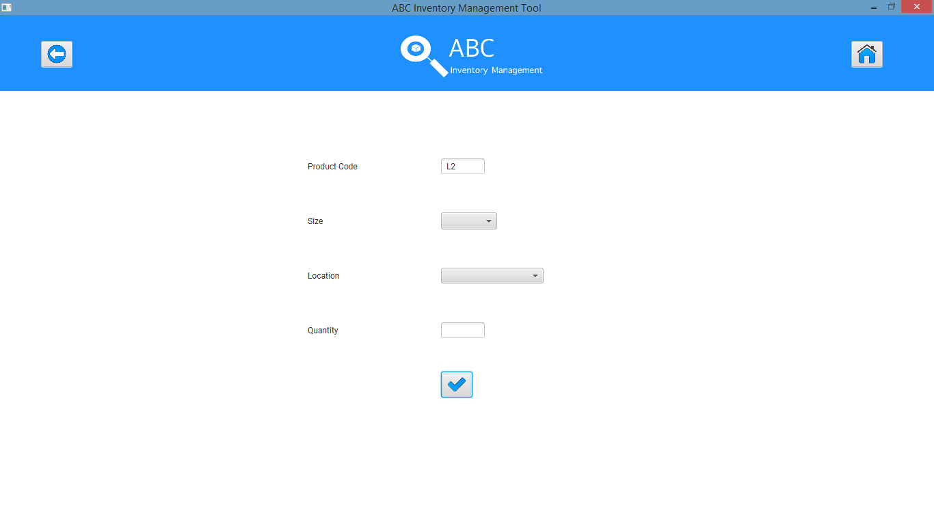

# APIT003- Add a Product Item from existing Product by entering accurate details but skip some details.

|  |  |  |  |  |  |
| --- | --- | --- | --- | --- | --- |
| **Test Name** | | Test add a Product Item from existing Product by entering accurate details but skip some details (Test APIT003) | | | |
| **Use Case Tested** | | Manage Product | | | |
| **Test Description** | | This test tests how the system reacts when the user skips a few details while adding a new product item. | | | |
| **Pre-Conditions** | | Users need be logged in as a Warehouse Staff (Warehouse Staff Access) in the Manage Product page  Meta data to store Product Item details in the database must exist. | | | |
| **Post-Conditions** | | System displays an appropriate error message and highlights the details that need to be entered. | | | |
| **Result (Pass/Fail/Warning/ Incomplete)** | | Pass | | | |
|  | **Test Step** | | **Expected Test Results** | **P** | **F** |
| 1. | Enter accurate details in all fields but skip a few details in the ‘Add Product Item/ Stored Product’ page. | | System waits until user clicks on ‘Add’ icon. | P |  |
| 2. | Click on ‘Add’ icon. | | System displays an error message prompting the user to enter all details. | P |  |
| 3. | Click on ‘Ok’. | | System highlights the details that need to be entered. | P |  |

## Data Set 1

|  |  |
| --- | --- |
| **Data Set 1** | |
| **Fields** | **Values** |
| **Product Code** | L2 |
| **Product Size** | M (L2300) |
| **Location** | Oxford Store |
| **Quantity** |  |

**Step 1**

Add Product Item/ Stored Product page is displayed for the selected Product.



Enter all details accurately except for quantity and click on ‘Add’.

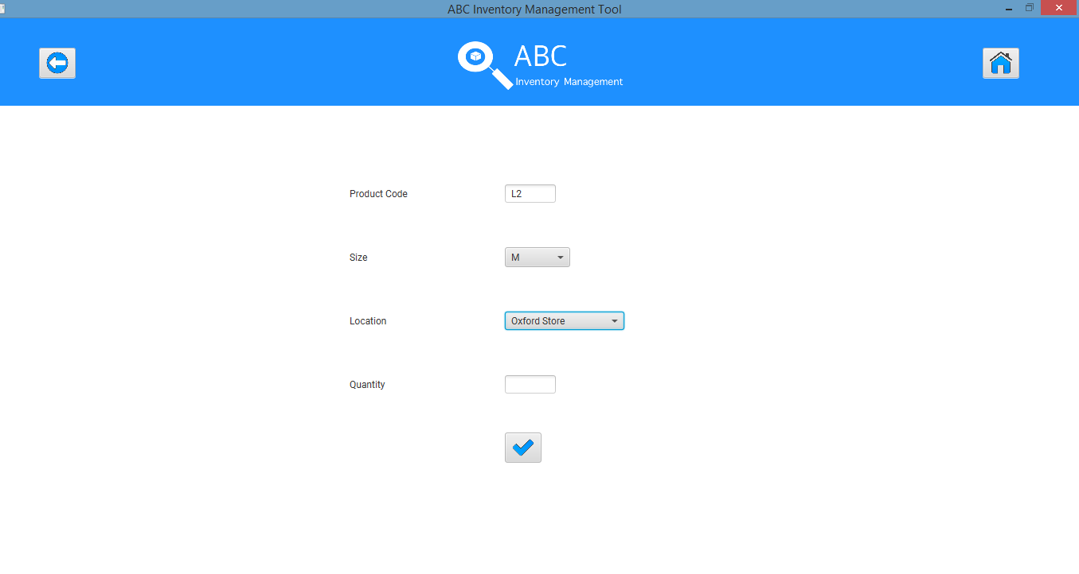

**Step 2**

System displays an appropriate message. User clicks on ‘Ok’.

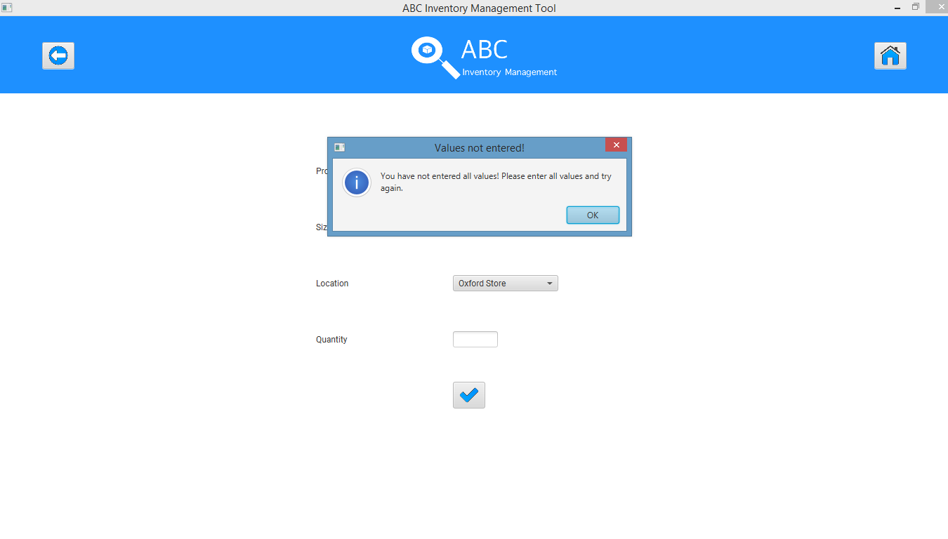

**Step 3**

System highlights the data that needs to be entered.

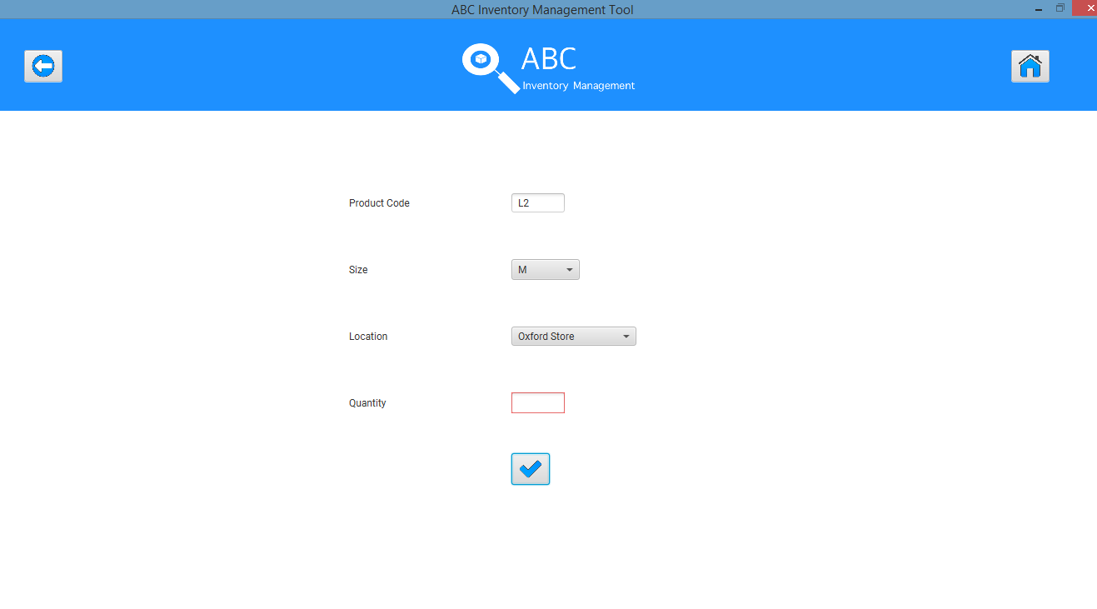

## Data Set 2

|  |  |
| --- | --- |
| **Data Set 2** | |
| **Fields** | **Values** |
| **Product Code** | L2 |
| **Product Size** |  |
| **Location** | Epping Store |
| **Quantity** | 4 |

**Step 1**

Add Product Item/ Stored Product page is displayed for the selected Product.



Enter all details accurately except for product size and click on ‘Add’.

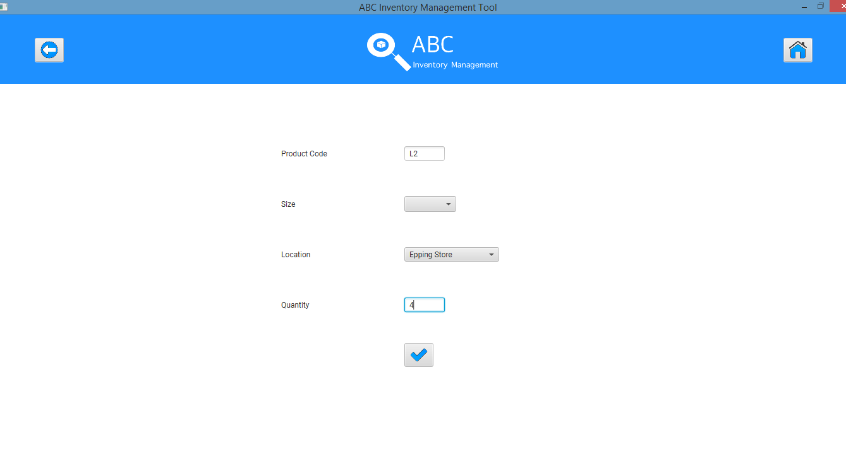

**Step 2**

System displays an appropriate message. User clicks on ‘Ok’.

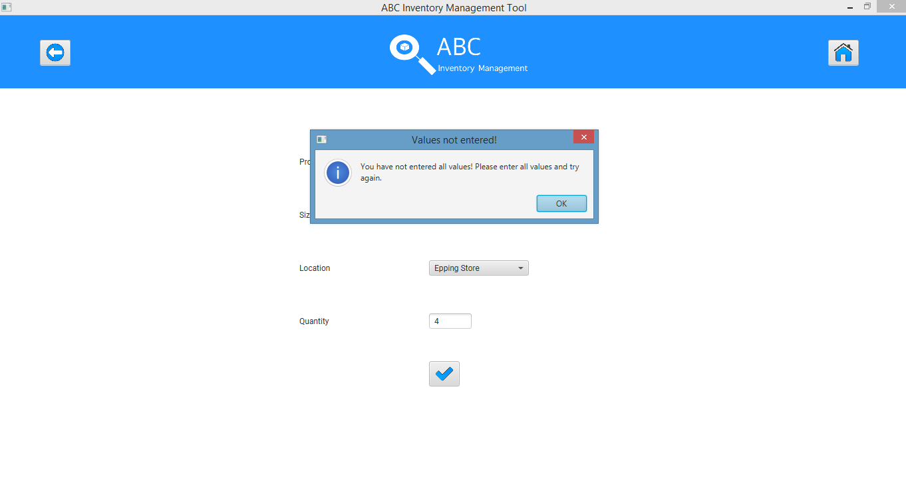

**Step 3**

System highlights the data that needs to be entered.

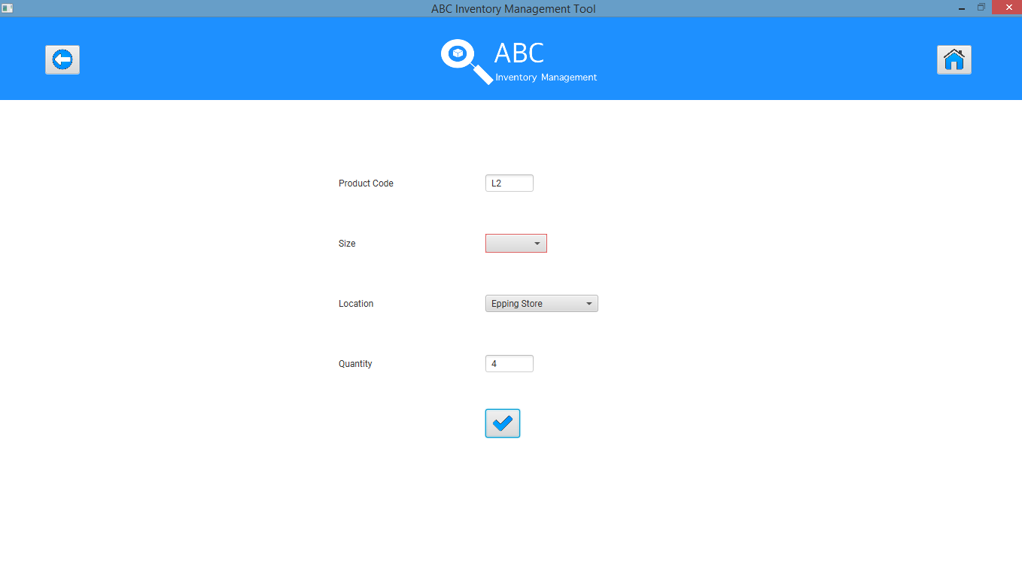

# APIT004- Add a Product Item from existing Product by entering invalid Quantity data

|  |  |  |  |  |  |
| --- | --- | --- | --- | --- | --- |
| **Test Name** | | Test add a Product Item from existing Product by entering invalid quantity data. (APIT004) | | | |
| **Use Case Tested** | | Manage Product | | | |
| **Test Description** | | This test tests how the system reacts when the user enters an invalid quantity data while adding a new product item. | | | |
| **Pre-Conditions** | | Users need be logged in as a Warehouse Staff (Warehouse Staff Access) in the Manage Product page  Meta data to store Product Item details in the database must exist. | | | |
| **Post-Conditions** | | System displays an appropriate error message, clears the quantity data and highlights it in red | | | |
| **Result (Pass/Fail/Warning/ Incomplete)** | | Pass | | | |
|  | **Test Step** | | **Expected Test Results** | **P** | **F** |
| 1. | Enter all details accurately but enter an invalid quantity value in the ‘Add Product Item/ Stored Product’ page. | | System waits until user clicks on ‘Add’ icon. | P |  |
| 2. | Click on ‘Add’ icon. | | System displays an error message prompting the user to enter a valid quantity value. | P |  |
| 3. | Click on ‘Ok’. | | System clears the quantity value and highlights it in red. | P |  |

## Data Set 1

|  |  |
| --- | --- |
| **Data Set 1** | |
| **Fields** | **Values** |
| **Product Code** | L2 |
| **Product Size** | XS(L2100) |
| **Location** | Oxford Store |
| **Quantity** | ABC (Non-numeral value) |

**Step 1**

Add Product Item/ Stored Product page is displayed for the selected Product.



Enter all details accurately but enter a non-numeral quantity value and click on ‘Add’ icon.

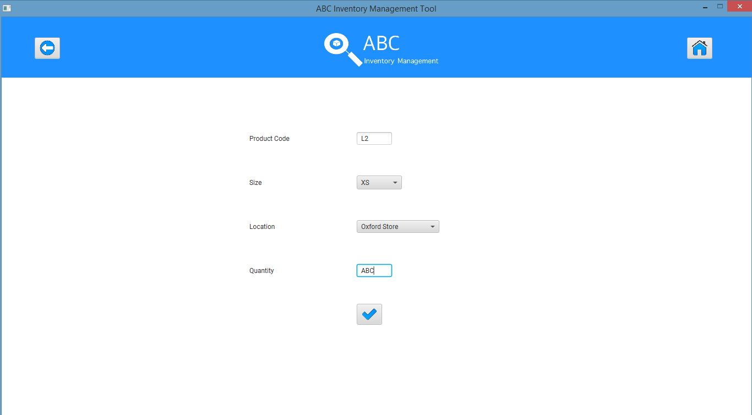

**Step 2**

System displays an appropriate error message and prompts user to enter a numeric quantity value.

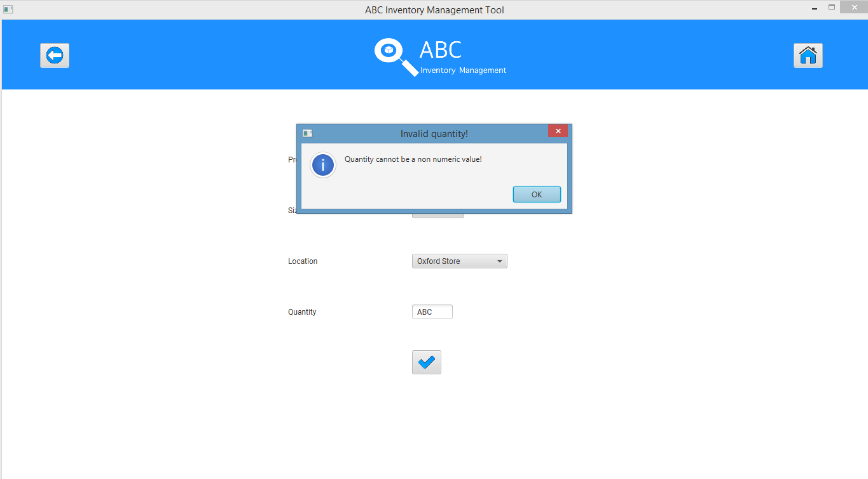

**Step 3**

System clears the quantity field and highlights it in red.

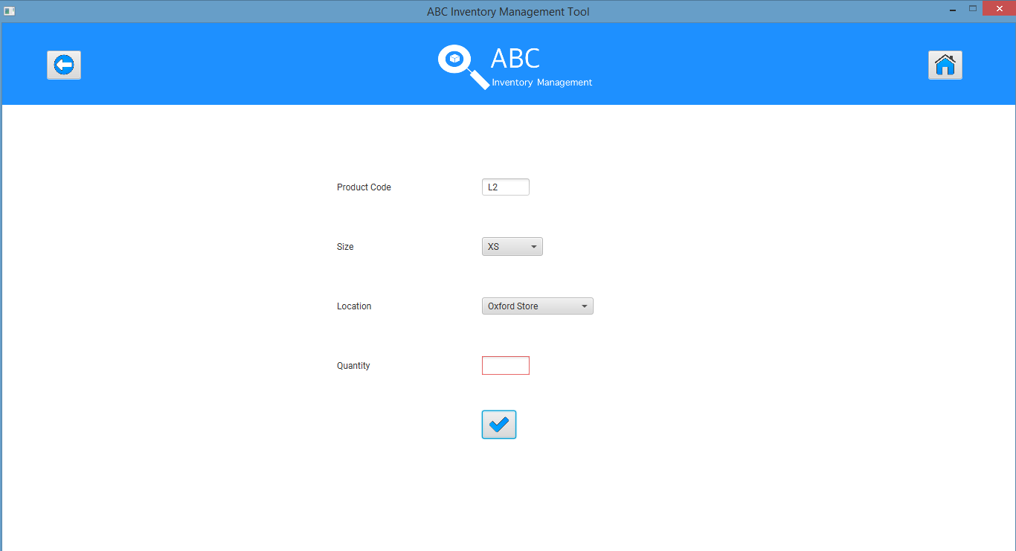

## Data Set 2

|  |  |
| --- | --- |
| **Data Set 2** | |
| **Fields** | **Values** |
| **Product Code** | L2 |
| **Product Size** | XS(L2100) |
| **Location** | Oxford Store |
| **Quantity** | -8 (Negative Value) |

**Step 1**

Add Product Item/ Stored Product page is displayed for the selected Product.



Enter all details accurately but enter a negative quantity value and click on ‘Add’ icon.

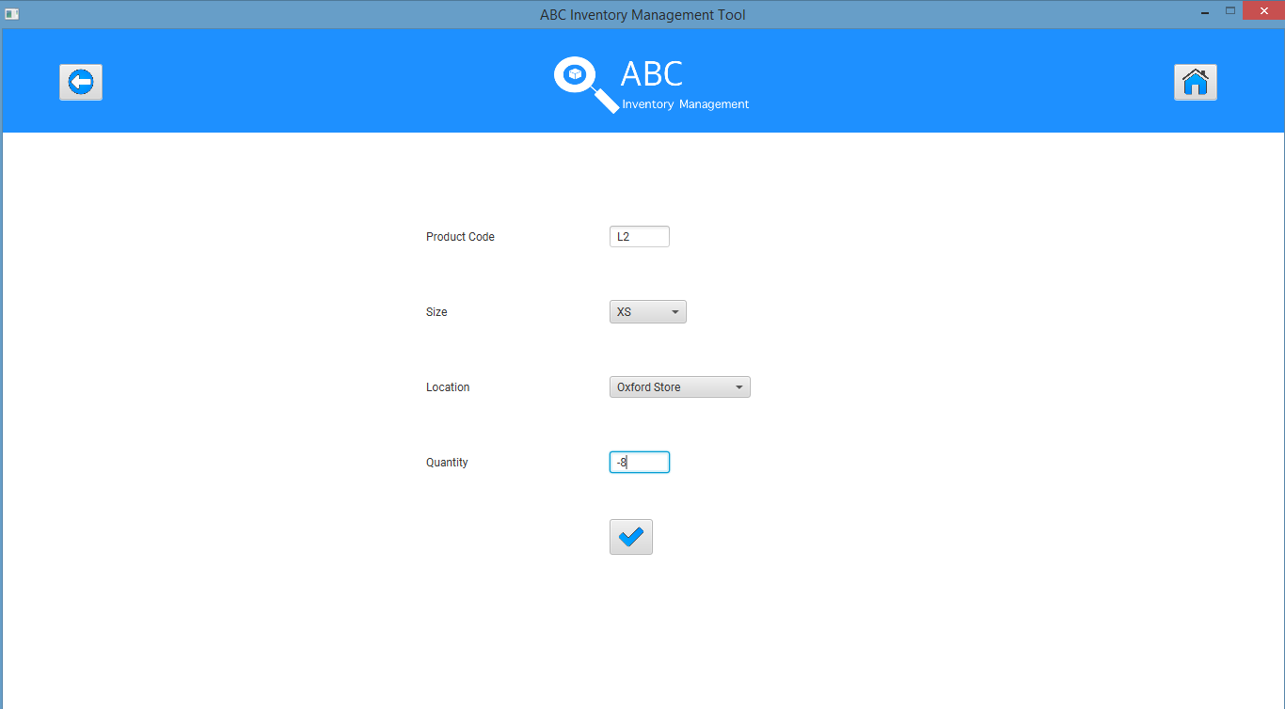

**Step 2**

System displays an appropriate error message and prompts user to enter a non-negative quantity value.

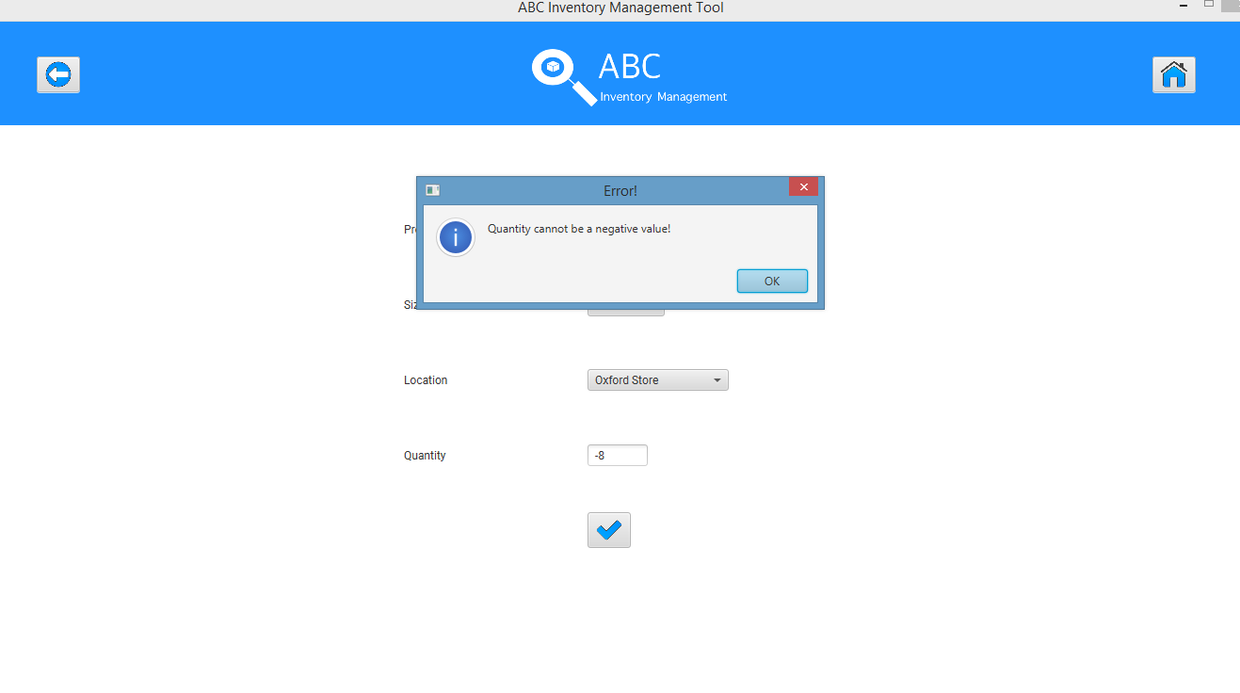

**Step 3**

System clears the quantity field and highlights it in red.

